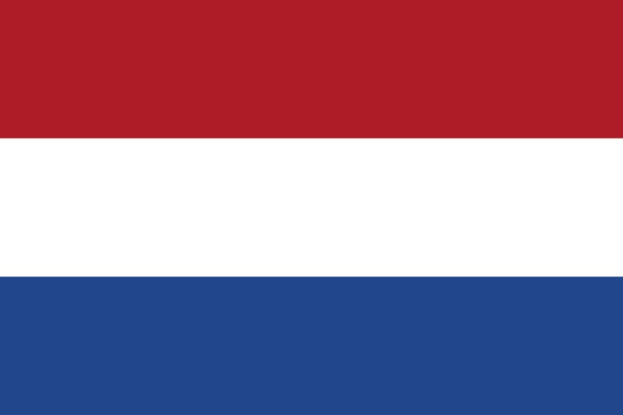 | Johannes “Johan” Schans, Honor Swimmer, Netherlands, 1970 | 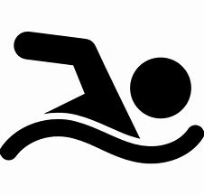

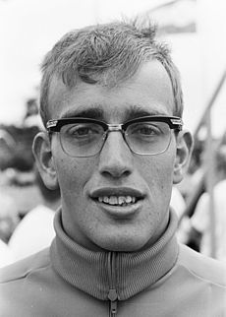
Videos: Interview 1

Johannes “Johan” Schans won 1 Major: 1970 World Professional Marathon Swimming Federation. He won and set the speed record in 1970 in the 16.1 km Hamilton race in 4 hours and 2 minutes.
He won 3 other professional races: 1973 16.1 km Chicago; 1970 42 km lac St.-Jean in 8 hours and 28 minutes; and 1775 80.5 km Nile. Johan was a close runner-up in the 1969 World Professional Marathon Swimming coached by IMSHOF Honoree Herman Willemse.
Johan competed four times in the 42 km Lac St-Jean and took 2nd in 1969 in 10 hours and 13 minutes. He swam the 57 km Santa Fe-Coronda in Argentina in 8 hours and 1 minute in 1969 and in 1974. He partnered and won in 1971, 1972 and 1973 with IMSHOF Honoree Horacio Iglesias at the La Tuque 2-person relay.
He competed in the 1968 Olympics in the 200 meter freestyle and relay pool events.
Expanded Biography (Openwaterpedia)
Long Swims Database (Marathon Swimmers Federation)

Dutch Translation
Johannes “Johan” Schans won 1 Major: 1970 World Professional Marathon Swimming Federation. Hij won en vestigde het snelheidsrecord in 1970 in de 16,1 km van Hamilton in 4 uur en 2 minuten.

Hij won nog 3 andere professionele wedstrijden: de 1973 16,1 km Chicago; de 1970 42 km Lac St.-Jean in 8 uur en 28 minuten; en de 1775 80,5 km Nijl. Johan werd nipt tweede bij de Wereld Professionele Marathon Zwemmen 1969 achter IMSHOF geëerde Herman Willemse.

Johan deed vier keer mee aan de 42 km Lac St-Jean en werd in 1969 2e in 10 uur en 13 minuten. Hij zwom de 57 km Santa Fe-Coronda in Argentinië in 8 uur en 1 minuut in 1969 en in 1974. In 1971, 1972 en 1973 won hij samen met IMSHOF Honoree Horacio Iglesias de 2-persoons estafette van La Tuque.

Hij nam in 1968 deel aan de Olympische Spelen op de 200 meter vrije slag en de estafettes.

